**Forget Me Not**

Game Design Document

Table of Contents:

1. Concept
2. Story

2.1 Premise

2.2 Themes

1. Characters

3.1 Rage

3.2 Depression

3.3 Anxiety

1. Gameplay

4.1 Core Gameplay

4.2 Controls

4.3 Character Loop

4.5 Abilities

1. Visuals

**Concept**

The game is envisioned as a puzzle-platformer for the PC aimed at a target audience of casual gamers between the age of 15-25. The player has to traverse a variety of levels in order to reach the end. He achieves this by switching between 3 characters and using their abilities in conjunction with each other.

**Story - Premise**

The story follows the characters Rage, Depression and Anxiety, personifications of a human's negative emotions, as they find themselves split apart from the rest of the emotions. In order to once again combine into a balanced state, they start their journey through a metaphorical representation of the human body to return to their previous home, the head.

**Story - Themes**

The game is split into multiple worlds, depending on where inside the body the characters are at the moment. These worlds are metaphorical representations of the body part they currently reside, e.g. A dark and unsettling cave-like area for the feet or an illuminated, heavenly sea of clouds for the head.

The games characters are all based on negative emotions, with the aim of showing multiple things. Firstly, this choice aims to show that negative feelings, like any others, do have their positive elements and can be used in a positive way. Secondly, the game highlights the importance and power of cooperation, seeing how the characters are only able to complete most of the levels by working together.

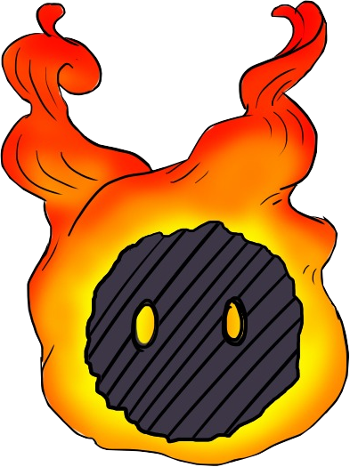

**Characters - Rage**

A small ball of anger that gets heated very quickly. It finds itself completely alone at the start of the game and can thus be considered the main character. Loses itself in anger once its ability is activated, causing it to dash forward in blind rage. Furthermore, its flames start burning even stronger. These effects can be used to e.g. break through certain walls or light up explosives.

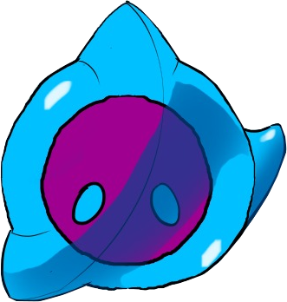

**Characters - Depression**

An accumulated mass of sadness that cries whenever it gets the chance. After being seperated from the other emotions, it simply started crying until Rage eventually met up with it. Starts to cry uncontrollably when its ability is activated, which can be used to

fill contains with water or as a jet-pack to reach high areas.

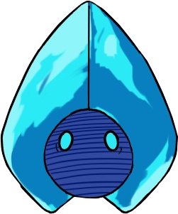

**Characters - Anxiety**

An easily frightened concoction of all kinds of fears. It froze up

once it realized that it was all alone until the others joined it.

It freezes in place once its ability is activated, causing it to

become invulnerable and making projectiles repel from it.

**Gameplay - Core Gameplay**

The main part of the game consists of solving puzzles in order to bring all characters within the level to the exit. These puzzles involve the use of physics (e.g. floating objects on water; see-saws; etc…), the use of mechanical and electrical mechanism (e.g. levers, buttons, switches, etc…) and the use of the characters' abilities.

**Gameplay - Controls**

The player can move the currently selected character by using the A and D keys to move right or left and the Spacebar to jump. In order to switch to a different character, he can either click on the character or press the Q/E key to cycle through the characters counter-/clockwise. To use an ability, the player has to click the icon appearing on the screen. This holds true for both individual or combined abilities.

**Gameplay - Character Loop**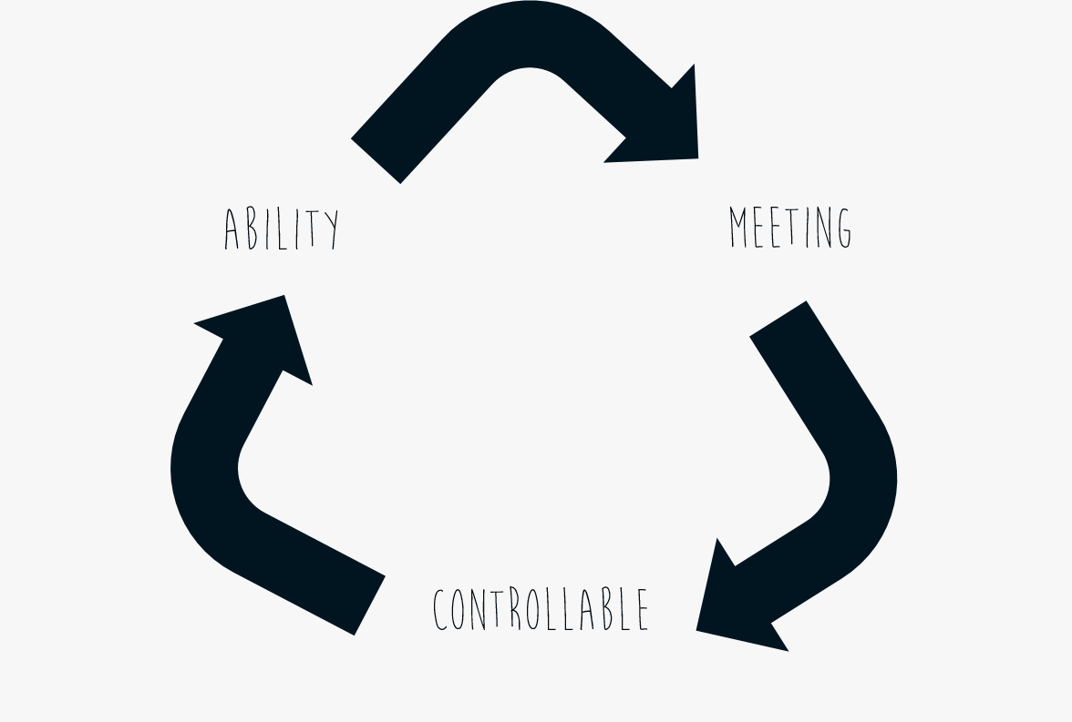

Within any given level, characters always follow a certain loop once their ability has been activated. Before using their ability, they can be fully controlled by the player. After the activated ability has finished its animation, the player can no longer control that character and the game automatically switches to another one. The player then has to make the characters meet up in order to regain control over both of them.

**Gameplay - Abilities**

Individual

Rampage (Rage Idv.): Makes Rage dash forward and his flames burn stronger

* Can run through breakable obstacles
* Can light flammable objects

Crybaby (Dep. Idv.): Makes Depression cry a huge amount of tears.

* Can fill up containers
* Can put our fires
* Can raise water levels
* Can be used as a jet-pack

Cold Feet (Anx. Idv.): Makes Anxiety freeze in place.

* Repels all projectiles
* Makes it invulnerable
* Can be used as a platform by other characters

Combination

Frozen Outrage (Rage&Anx.): Combination runs very fast and becomes invulnerable

* Can run over hazardous terrain
* Can run through enemies to defeat them
* Can destroy any obstacle

Eruption (Rage&Dep.): Combination cries magma tears that harden immediately.

* Can be used to create paths

Icey Tears (Dep.& Anx.): Combination can shoot controllable frozen tears.

* Can defeat enemies from a distance
* Can activate unreachable mechanisms

**Visuals**

The game features a striking contrast between the soft, more washed out and dim backgrounds and the bright and colorful characters and animations.

